K-NN Classification of Fruits Dataset - Results

1. Model set-up:

Dimensions of Train dataset: (44, 3)

The accuracy of the 5-NN classifier on test data: 53.33 %

Dictionary mapping different fruits in the dataset:

{1: 'apple', 2: 'mandarin', 3: 'orange', 4: 'lemon'}

1. Model predictions of random data input:

A fruit with a mass of 20g, width 4.3 cm, height 5.5 cm is classified as: mandarin

A fruit with a mass of 100g, width 6.3 cm, height 8.5 cm is classified as: lemon

1. Accuracy vs ‘K’:

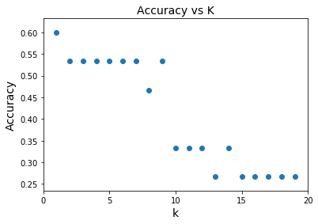

1. Accuracy vs Test-Train split

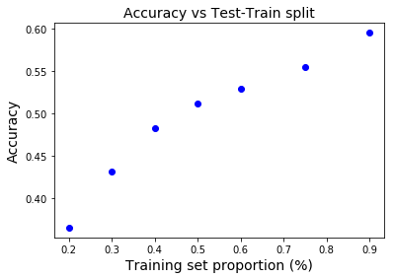

1. Classification Accuracy after MinMax Scaling

Accuracy of K-NN classifier on training set after scaling: 95.45

Accuracy of K-NN classifier on test set after scaling: 100.00

Predicted fruit type for [[5.5, 2.2, 10, 0.7]] is orange